Presentation attacks against biometric authentication (**T137)**

User Candidate Number: 15086

**PRESENTATION ATTACK AGAINST BIOMETRIC AUTHENTICATION**

**Abstract**

In this paper, I will explore the concept of “Presentation attacks” or spoofs, aim to provide an overview of recent discussions and literature in the field, and will discuss potential presentation attacks examples in different biometric technologies including facial recognition, face, iris, voice, hand writer recognition and hand geometry.

**What is Biometrics Technology**

Mankind is capable to recognize someone from his/her sound, face, gait, odor, etc. The biometric recognition technology is similar to human being’s recognition system. For example, face recognition technique, speech recognition technique is very similar. The biometric recognition systems are fundamentally imitating human being’s recognition systems. (Wang, 2011**).** Biometrics has been defined by ISO (the International Organization for Standardization as followed:

*“Biometric technologies are used to recognize individuals based on biological and behavioral characteristics and, consequently, are often used as a component in security systems. A biometric technology assisted security system may attempt to recognize persons who are known as either friends or foes or may attempt to recognize persons who are unknown to the system either”* (ISO/IEC 30107-1, 2016)

**Why are biometrics important?**

According to NIST (National Institute of Standards and Technology), “biometrics are used to secure facilities, protect access to computer networks, counter fraud, screen people at our borders, and fight crime. Also, biometrics are used to manage identities for; first responders at the scene of natural disaster, border patrol, soldiers in theater and police officers on the street*.*” ***(Flanagan, 2018)***

**Biometric authentication**

One of the most effective and accurate methods of verifying an individual’s identity is by analyzing a unique personal attribute or behavior with biometric authentication systems. This technology is very complicated; therefore, it is not cheap and very complex than the other kind of identity verification processes **(Harris & Maymi, 2016)**. Based on the behavior of individuals, a biometric system can make authentication decision, such as signature dynamics, voice, keystroke dynamics, gaits etc., but these can change over time and possibly be counterfeit. Biometric systems based on physical characteristics (such as iris, retina, or fingerprinting) provide more accuracy, because physical characteristics are often unchanged, absent some deform injury, and harder to imitate.

Biometrics are usually divided into two different categories **(Harris & Maymi, 2016)**. The physiological is the first category of biometrics. These are physical characteristics specific to a particular person. As a common example of a physiological feature fingerprint is being used widely in biometric systems.

The behavioral characteristics is the second category of biometrics. This kind of biometrics are based on the individuals’ behaviors to confirm his/her identity. For example, signature dynamics are widely known a behavioral characteristic which has been used for verification.

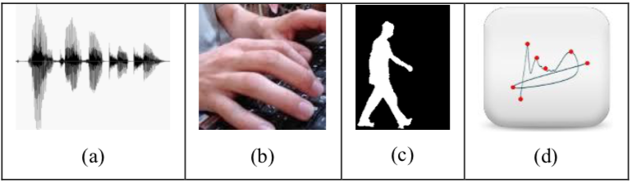

*Figure 1[1]. Behavioral characteristics; a) sound, b) keyboard strokes, c) gait, d) signature*

An individual’s physiological or behavioral characteristic is scanned by a biometric system. After this process the data is compared to a record which has been created earlier enrollment process. The grooves of a person’s fingerprint, the pattern of someone’s retina, or the pitches of someone’s voice is inspected by this system, because of this, it must be extremely sensitive. The system must provide accurate and repeatable measurements of physiological or behavioral characteristics of the individuals. If the system must not be calibrated, so false positives and false negatives occur frequently, and the results are not as accurate as possible. So, the system must be calibrated by the authority **(Harris & Maymi, 2016).**

**Biometric Features**

The biometric features have a few attributes. Those are mentioned by Wang (2011) as following characteristics;

1. Universality; everyone has the features.
2. Distinctiveness; the features which could be used to distinguish different identities.
3. Permanence; the features would not change over time.
4. Collectability; the features could be gathered together via a biometric system.

In other words, we ca translate these characteristics with fingerprint example: Everyone has fingerprint and everyone’s fingerprint is unique, fingerprint does not change over time and biometric systems can easily collect fingerprint data from individuals.

**Biometric Modalities and Examples**

Fingerprint, face, iris, voice, hand writer recognition and hand geometry are commonly implemented or studied biometric modalities. Many factors must be calculated when implementing a biometric device, because there is not one biometric modality that is best for all. Another important point that biometric modalities are in changing stages of maturity.

**(Ulery, B. T., Hicklin, R. A., Roberts, M. A., & Buscaglia, J. (2017))**



*Figure 2[2] a) Face and iris recognition are used in India b) Iris recognition is used border-crossing in UAE c) Fingerprint recognition system is used in USA*

**Facial Recognition**

Key features of the face are recorded by facial recognition as the spatial geometry of distinguishing features of the face. Different methods for face recognition are used by the vendors. But all of them are focusing the distinguishing features of the face. A camera from some distance away can capture an individual’s face (Woodward, John D., Horn C., Gatune J., and Thomas A.,(2003)). Face recognition is widely used in airports and subways thanks to the technology’s offering in the field.

**Retina**

Retinal recognition creates an "eye signature" from the vascular configuration of the retina, which is assumed to be a characteristic of each person eye and each eye. This is one of the safest biometrics since it is not easy to change or replicate the retinal vasculature in an eye itself. Image acquisition requires a person to look at a lens in an alignment target, so that the subject is co-operative. In addition, retinal scan may reveal certain medical conditions and the public acceptance can be questioned (Delac, K. and Grgic, M. (2004)).

**Fingerprint**

The tip of each finger has pattern of ridges and furrows is called fingerprint. For many centuries fingerprint was used for personal identification wherefore the matching accuracy was very high. Patterns were extracted by inked impression of the fingertip on paper. Now, digital images of these patterns are provided by compact sensors (Delac, K. and Grgic, M. (2004)). For identification, fingerprint recognition is achieved by direct scanning of the finger by a direct contact with a reader device that can control for verification features such as temperature and pulse. In real-time authentication systems, images obtained by the sensors are used by the attribute subtraction module to calculate property values (Delac, K. and Grgic, M. (2004)). The property values typically correspond to the position and direction of certain critical points known as minutia points. The pairing process involves comparing the two-dimensional minutiae patterns extracted from the user's print with those in the template. A problem with existing fingerprint recognition systems is that they need a large amount of computing resources (Delac, K. and Grgic, M. (2004)).

**Palm Print**

Many of the same fingerprint recognition characteristics is also used for palm print recognition. A high-resolution palmprint scanner that would collect all the features of the palm such as hand geometry, principal lines, and wrinkles for a highly accurate biometric system (Delac, K. and Grgic, M. (2004)). Palmprint is expected to be even more reliable than fingerprint since palm is larger than a finger. Palmprint scanners are more expensive than fingerprint scanners because they need to capture larger area with a similar quality as fingerprint scanners (Delac, K. and Grgic, M. (2004)).

**Voice**

Individual’s voice features are based on physical characteristics such as tracts, mouth, nasal cavities and lips that are used in creating sound. These characteristics of the human speech are immutable to an individual, but the behavioral part age, medical conditions, and emotional state change over time (Delac, K. and Grgic, M. (2004)).

Voice recognition techniques are usually categorized according to two approaches: 1) Automatic Speaker Authentication (ASV) and 2) Automatic Speaker Identification (ASI) (Delac, K. and Grgic, M. (2004)). Speaker validation uses sound as an authentication feature in a two-factor scenario. The speaker ID tries to use sound to determine who an individual actually is. Voice recognition distinguishes a contact by matching certain voice properties against templates stored in a database. The sound systems must be trained to the voice of the person and to more than one person during the recording period. The recording session is usually required. Feature extraction typically measures characters or sound characteristics that are unique to each person's vocal path (Delac, K. and Grgic, M. (2004)). Pattern matching algorithms used in voice recognition are similar to those used for face recognition.

**Biometric Enrollment and Verification**

A biometric system fundamentally is a pattern recognition system that senses individual’s behavioral and physiological specifics as biometric signal, processes the signal to take out a set of important features, then compares these features against the feature set stored in a database, later based on the biometric signal, makes a decision about the identity of the person. *Figure 3* shows this process clearly.



*Figure 3[3]). Biometric enrollment and verification a) Enrollment phase b) Verification phase*

**BIOMETRIC SYSTEM VULNERABILITY**

To prevent any potential security crisis, the biometric system should be identified and systematically addressed. There are different methods of vulnerability that can be analyzed. Biometric recognition systems are prone to deliberate attacks, as well as unintended security delays, which could lead to theft of sensitive information such as illegal attacks, sabotages or biometric templates of users registered to the system. There can be many factors that lead to such security delays. A biometric system is susceptible to different types of attacks, endangering security provided by the system, causing system failure (Delac, K. and Grgic, M. (2004).

In spite of biometric systems advantages, like any other security applications, they are in danger against various attacks (Joshi, M., Mazumdar B. & Dey S. (2018)). Biometric systems are attacked by attackers usually to hide their identities, for the purpose of achieving another individual’s privileges, or sharing a biometric and its following benefits with multiple people.

Here we discuss types of attacks against biometric systems, then explain presentation attacks in another saying “spoofing” with examples.

**Types of Attacks**

Attacks against biometric systems divided into two categories: indirect attacks and direct attacks (presentation attacks).

**Direct attacks** are type of attacks also known as presentation attacks. Presentation attacks are attacks against the biometric authentication devices at the sensor level (Raghavendra, R., & Busch, C. (2014). According to ISO (*the International Organization for Standardization*) presentation attackis defined as followed: “*Presentation of an artefact or human characteristic to the biometric capture subsystem in a fashion that could interfere with the intended policy of the biometric system.*” (ISO/IEC 30107-1, 2016). As shown in the figure 4 phase 1 below, presentation attacks are occurred externally at the sensor level by the attackers. As a consequence, they don’t require digital protection techniques such as encryption, digital signatures and hashing.

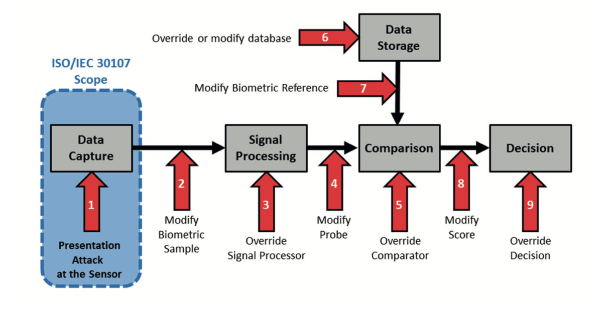

*Figure 4[4] —This figure shows presentation attacks are made on the first part (Data Capture) of the system which is called sensor level.*

However, **indirect attacks** are performed inside the system by the attackers by bypassing the signal processing (point 3 in Figure 4) or comparison (point 5 in Figure 4), or manipulating templates in the database in Data Storage (point 6 in figure 4), or exploiting possible weak points in the communication channels by modifying biometric sample, probe, score, biometric reference (points 2, 4, 7 and 8 in Figure 4). Without doubt, indirect attacks require advanced programming skills (Jain, R. & Kant, C. (2015)).

**Presentation Attacks (Direct attacks)**

With the wide distribution of biometric systems, the threat of presentation attacks increased. An impostor gains illegitimate access and advantages by presenting as a legitimate user by replacing that victim’s biometrics. Presentation attacks are also commonly known as *“biometric spoofing” (Jain, R. & Kant, C. (2015)).* Spoofing attackers don’t require advanced technical skills, as a consequence spoofing attacks have considerable practical relevance. The vulnerability of biometrics spoofing is listed on The US National Institute of Standards and Technology’s National Vulnerability Database ().

Many types of biometrics are vulnerable to presentation attacks. Such as the face, iris, and fingerprint images captured from a presentation attack look similar to the images captured from the real user. Why detecting spoofing attacks so difficult is demonstrated below in the figure 5.



Figure 5[5]. a) Real face, iris, and fingerprint samples b) a spoofing attack.

Use of an artificial biometric or artefact to spoof a biometric system is a one category of presentation attack which is shown as in figure 5. This kind of spoofing attacks are performed very easily and with low cost materials which can be found publicly***.*** (Schuckers, S. (2016))

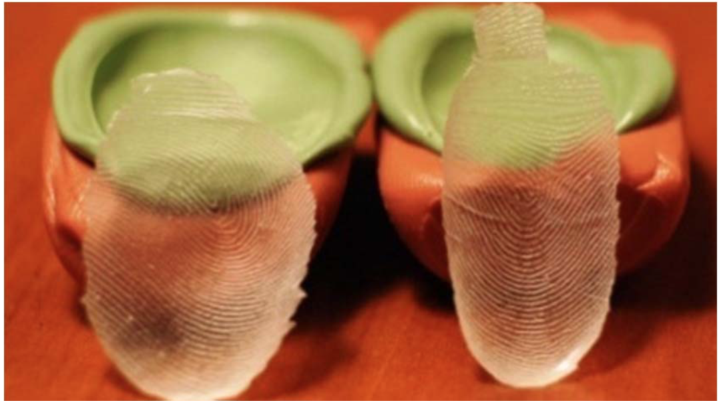

**Figure 1**. This spoofing item made by silicon and shows victims fingerprint.

Another category is use of victim’s cadavers or body parts for example, fingers, eyes for attacking against iris scanners, ears etc. and also plastic surgery or mutilation could be used to have same or familiar face or other body part of victim by attackers (Schuckers, S. (2016)). For example, with having face implant operation, attacker could have imitated victim’s face, with face transplant attacker could have exactly same face as victim and other body part transfer operations could also be performed by attackers. Those kinds of attacks could be high cost because of surgery operations are not cheap and not easy to perform as the first type.

**Face Spoofing Attacks**

The face as a commonly biometric parameter is used widely for personal and commercial applications such as access to mobile phone, laptop, personal computers etc... Face biometric, compared to other biometrics such as fingerprint, iris, and palm, etc. is known about many people due to its accessibility. But attackers impersonate easily the face recognition systems because of this well-known advantage. there is also the weakness for the unwanted situations. Biometric systems have more vulnerabilities. On the other hand, biometric techniques have more accuracy.

It is very easy to create such an attack because victim’s photos and videos can be easily found through social networks or the image or the video can be captured from distance. By displaying photos or videos against the sensor, attacker can gain access the system through unauthorized channels.



Figure 6[6]. a) print attacks b) video attacks

For face spoofing attacks attackers use two methods: 2D spoof and 3D spoof. Photo attacks and video attacks are classified in 2D attacks (ref?).

Photo attacks can be performed as the photo of the victim is shown to the biometric system’s sensor (camera) to gain access the system such as mobile phone, laptop, etc. by attackers. Before the attack this photo could have been captured by camera or took from social media such as Facebook, Instagram, Twitter, etc. by the attackers. Also attacks against face biometrics can be performed with photographic masks which are high-resolution prints of eyes and mouth are morphed. When the attack is occurred, the impersonator is placed behind of the sensor so certain face movements are reproduced (Kumar, S., Singh, S., & Kumar, J. (2017)).

Video attack is similar with photo attack. This can be performed by playing the video of the victim to the sensor (camera). Due to proper movement of the face part, attacker can access the biometric modality (Kumar, S., Singh, S., & Kumar, J. (2017)). This video could be captured by video camera or could be taken through another way such as social media by attackers. However, these types of attacks are more difficult to identify or detect than photo attacks (Kumar, S., Singh, S., & Kumar, J. (2017))

The 3-D mask attack due to the depth elements in the facial features, is more developed version of video and photo attacks. This type of attack is made a 3-D mask of the person who is being impersonated by attacker. Thus, making it more problematic to develop fixes against the spoofing (Kumar, S., Singh, S., & Kumar, J. (2017)). Compared to the other categories, these attackers are less widespread. They also prepare 3-D masks different materials and different sizes. Plastics, papers, silicones are commonly used materials by 3-D makers (Z. Akhtar, C. Micheloni, and G. L. Foresti (2015).



Figure 7[7]: General face spoofing attacks

Additionally, media groups, hackers, universities have drawn attention to presentation attacks. For example, in 2017 on November 3 Apple has released iPhone X. It came with a new type of password authentication called Face ID. This new authentication method provides the users to unlock their mobile phone with their face (Gajanan, M. (2017, September 12). Also users can be verified for all applications even banking applications (as DNB Finger ID) without entering the required password, by this new face recognition technology. Face ID technology uses dot projector and infrared camera [Figure 2] for creating user’s face shape in 3D. Apple claims that this is the most advanced face recognition system used in the phone so far (About Face ID advanced technology. (2018, October 06)).

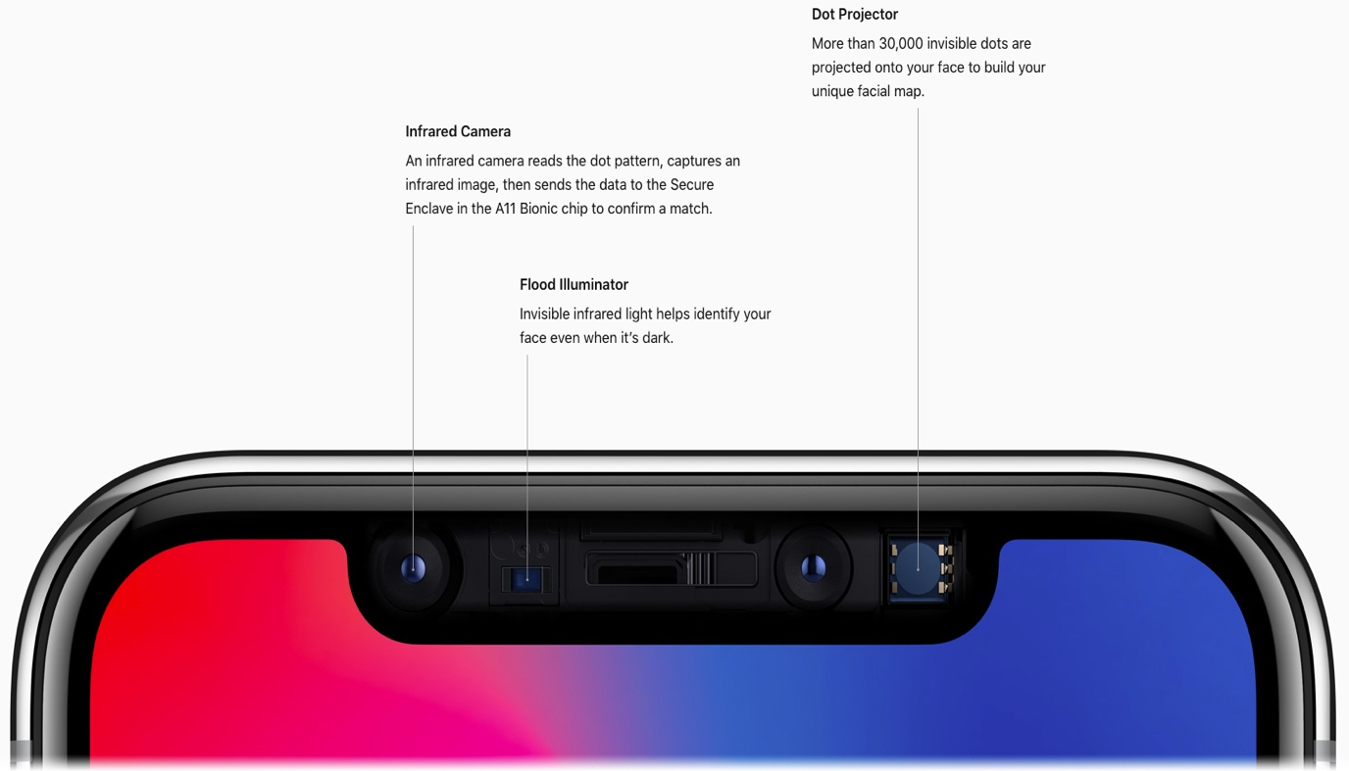

Figure 8[8]. iPhone X’s Face ID technology uses infrared camera, dot projector and flood illuminator.

Unfortunately, a week later Face ID cracked with a 3-D printed composite mask by Vietnamese security firm. They have released a blog post and video demonstrating that all.

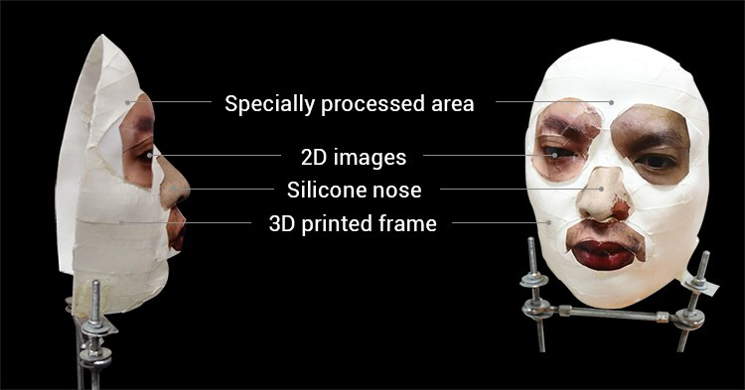

Figure 9[9] : Face ID cracked with a 3-D printed composite mask

Figure 8. The figure shows how attacker has created the mask for attack against the Face ID (Greenberg, A. (2017, November 27)).

**Fingerprint Spoofing**

Biometric authentication systems based on fingerprint recognition are commonly used. Consequently, fingerprint spoofing is also highly popular and old practice. Fingerprint spoofing can be performed by using legitimate user’s a 2-D fake fingerprint, a synthesized 3-D fake fingerprint, a reverse-engineered image from the fingerprint, or the finger itself which has been chopped off from the legitimate user’s body or the legitimate user’s cadaver fingerprint .

Using widely available materials such as gelatin fake fingerprints consensually or non-consensually can be fabricated. The user lets someone create spoofed fingerprint directly (also called cooperative or direct casts), is called the consensual method(Jain, R. & Kant, C. (2015)). Someone takes the spoofed fingerprints from the legitimated user’s dormant fingermarks, in consequence their cooperation not required (noncooperative or indirect), is called the non-consensual method. (Z. Akhtar, C. Micheloni, and G. L. Foresti (2015), “Biometric liveness detection: challenges and research opportunities,” IEEE Security & Privacy, vol. 13, no. 5, pp. 63–72.)

Since 2009 eighth spoofing attacks have been reported against active identity management systems in Japanese airport by people who arrived from South Korea used a special tape on her fingers to fool fingerprint recognition system in Japan (Maeda, Y., Yano, M., & YOMIURI SHIMBUN. (n.d.))

According to BBC in 2013 a Brazilian doctor was arrested after she caught on camera using silicon finger to sign in the biometric authentication device for work for absent colleagues. (Doctor 'used silicone fingers' to sign in for colleagues. (2013, March 12)).

**Iris Spoofing**

Iris recognition is generally considered to be the most accurate person identification method. Unfortunately, an iris photograph or video, a painted contact lens, a glass or plastic artificial eyeball, a reverse-engineered iris image based on the legitimate user’s iris or a real eye removed form legitimate user’s body could be used for tricking the iris recognition systems (r). **Figure 9** shows how to spoof iris recognition with artificial eyeball.

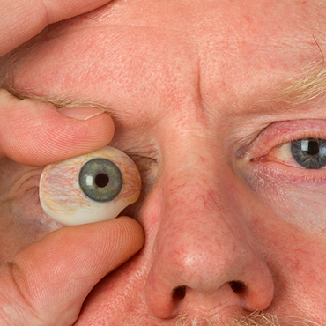

**Figure 9**[10] shows how to spoof iris recognition with artificial eyeball.

**Voice Spoofing**

A speaker verification system is expected to be safe not only for regular users, but also against spoofing attacks. The possible spoofing attack takes place at two points: the sensor level and the transmission of the detected signal. At the sensor level, an impostor can fool the system by imitating of someone at the microphone and at the transmission time, audio signal can be exchanged with a synthetically generated signal or imitated sound. Generally, the spoofing attack is to use a falsifying speech signal as a system input for attribute extraction and verification, and thus presents a threat to speaker authentication systems.

As digital recording becomes widely available, the replay attack is the simplest way to deceive a speaker verification system. The replay attack involves repeating a sample created by combining basic conversation sections from a pre-recorded speech instance or a specific target speaker. Indeed, it has been shown that the repetitive attack is an effective way to deceive text-free identifiers that do not impose restrictions on linguistic content (Wu, Z., & Li, H. (2013)). However, the replay technique is not flexible in constructing specific expressions required by text-dependent speaker verification systems.

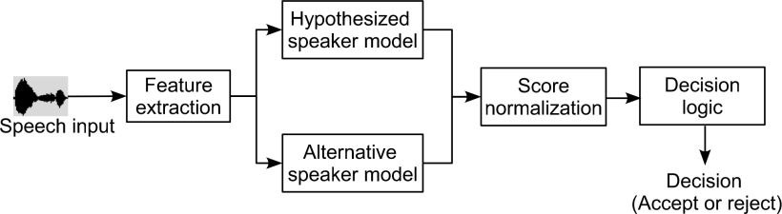

**Figure 11** [11]presents how to voice recognition system works

In 2017 BBC Click reporter Dan Simmons set up his voice ID for access his personal HSBC bank services. This voice-based security service is provided by HSBC and introduced in 2016. According to HSBC it measures one hundred different characteristics of human voice to verify user’s identity for give access to the system. HSBC claims that the system is secure because each persons’ voice is unique. Dan Simmons’ non-identical twin presented his voice as brother’s voice. But the bank let him access to the brother’s personal banking services via telephone. Fortunately, the system did not allow his twin to withdraw money, but he was able to access balances and rent transactions and was offered the change to transfer money between accounts (Simmons, 2017).

**Conclusion**

In this paper, I attempted to provide a general overview of presentation attacks on biometric recognition systems.  Despite their recent history, the technologies in the field has been widely used and been getting widespread in every part of our lives.

As in every security systems, it is possible to make attacks against these systems. As mentioned above briefly, the most common methods of attacks can take place in various forms such as imitation of the biometrical sources such as finger print and face, and also attacks against the software system of the biometrical security infrastructure.

Despite the technologies promising prospect in practical areas such as high security public areas, banking activities, travel and tourism, and Internet activities requiring identity verification, infinite possibility of potential attacks methods make us approach to the technologies with great caution.

In addition to the classical presentation attack methods which were presented above, the impressive developments in AI technology brings an interesting or more complicated dimension to the threat against the biometric security technologies. Thinking of an AI system, which is pivotal to visual manipulations and to massification the system attacks, there is a need in the field to revise the complexity of spoofs. The recent example from researchers at the University of Washington, who have produced a photorealistic former US President Barack Obama with the help of Artificial intelligence (Fake Obama created using AI tool to make phoney speeches , 2017) tells us this interesting complexity and possibilities of faking when the spoofs are supported with AI technology.

**References**

Patrick S.P. Wang Pattern Recognition, Machine Intelligence and Biometrics p.608

Harris, S., & Maymí, F. (2019). CISSP exam guide. New York: McGraw-Hill Education.

Flanagan, P. A. (2018, July 11). Biometrics. Retrieved from <https://www.nist.gov/programs-projects/biometrics>

Ulery, B. T., Hicklin, R. A., Roberts, M. A., & Buscaglia, J. (2017). Factors associated with latent fingerprint exclusion determinations. Forensic Science International, 275, 65-75. doi:10.1016/j.forsciint.2017.02.011

Woodward, John D., Horn C., Gatune J., and Thomas A.,(2003). Biometrics: A Look at Facial Recognition. Santa Monica, CA: RAND Corporation, https://www.rand.org/pubs/documented_briefings/DB396.html.

ISO/IEC JTC1 SC37 Biometrics. 2016. ISO/IEC 30107-1:2016. Information Technology - Biometric Presentation Attack Detection - Part 1: Framework. International Organization for Standardization.

Z. Akhtar, C. Micheloni, and G. L. Foresti, “Biometric liveness detection: challenges and research opportunities,” IEEE Security & Privacy, vol. 13, no. 5, pp. 63–72, 2015.

Kumar, M., & Vaisla, K. S. (n.d.). (2017). To study of various security attacks against Biometric template in a generic Biometric Recognition System.

Turhan C., Ceyhan, E., Sağıroğlu Ş., Biyometrik Sistemlerde Güvenlik Üzerine Bir İnceleme, www.iscturkey.org, access: 03.03.2016.

Delac, K. and Grgic, M. (2004) ‘A survey of biometric recognition methods’, 46th International Symposium Electronics in Marine, ELMAR-2004, Zadar, Croatia.

Joshi, M., Mazumdar B. & Dey S. (2018). 'Security Vulnerabilities Against Fingerprint Biometric System'

Fake Obama created using AI tool to make phoney speeches. (2017, July 17). Retrieved October 2018 from <https://www.bbc.com/news/av/technology-40598465/fake-obama-created-using-ai-tool-to-make-phoney-speeches>

Simmons, D. (2017, May 19). BBC News. Retrieved from <https://www.bbc.com/news/technology-39965545>

Schuckers, S. (2016). Presentations and attacks, and spoofs, oh my. Image and Vision Computing, 55, 26-30. doi:10.1016/j.imavis.2016.03.016

Vitulano, S., & Roli, F. (2005). Image analysis and processing, ICIAP 2005: 13th international conference: Cagliari, Italy, September 6-8, 2005: Proceedings. Berlin: Springer.

About Face ID advanced technology. (2018, October 06). Retrieved from <https://support.apple.com/en-za/HT208108>

Gajanan, M. (2017, September 12). IPhone X and iPhone 8 Price - How Much Do They Cost? Retrieved from <http://time.com/4937143/iphone-x-8-price-cost>

Kumar, S., Singh, S., & Kumar, J. (2017). A comparative study on face spoofing attacks. 2017 International Conference on Computing, Communication and Automation (ICCCA). doi:10.1109/ccaa.2017.8229961

Greenberg, A. (2017, November 27). Hackers Say They've Already Broken Face ID. Retrieved from https://www.wired.com/story/hackers-say-broke-face-id-security/

Maeda, Y., Yano, M., & YOMIURI SHIMBUN. (n.d.). At least 8 have entered Japan from South Korea using special tapes over fingerprints. Retrieved from <https://www.stripes.com/news/at-least-8-have-entered-japan-from-south-korea-using-special-tapes-over-fingerprints-1.102742>

Doctor 'used silicone fingers' to sign in for colleagues. (2013, March 12). Retrieved from https://www.bbc.com/news/world-latin-america-21756709

1. Turhan C., Ceyhan, E., Sağıroğlu Ş., Biyometrik Sistemlerde Güvenlik Üzerine Bir İnceleme, www.iscturkey.org, access: 03.03.2016.
2. Z. Akhtar, C. Micheloni, and G. L. Foresti, “Biometric liveness detection: challenges and research opportunities,” IEEE Security & Privacy, vol. 13, no. 5, pp. 63–72, 2015.
3. Z. Akhtar, C. Micheloni, and G. L. Foresti, “Biometric liveness detection: challenges and research opportunities,” IEEE Security & Privacy, vol. 13, no. 5, pp. 63–72, 2015.
4. ISO/IEC JTC1 SC37 Biometrics. 2016. ISO/IEC 30107-1:2016. Information Technology - Biometric Presentation Attack Detection - Part 1: Framework. International Organization for Standardization.
5. Z. Akhtar, C. Micheloni, and G. L. Foresti, “Biometric liveness detection: challenges and research opportunities,” IEEE Security & Privacy, vol. 13, no. 5, pp. 63–72, 2015.
6. Kumar, S., Singh, S., & Kumar, J. (2017)
7. Kumar, S., Singh, S., & Kumar, J. (2017)
8. https://www.apple.com/
9. Greenberg, A. (2017, November 27).
10. https://fcw.com/articles/2013/10/28/biometric-spoofing.aspx
11. Wu, Z., & Li, H. (2013)